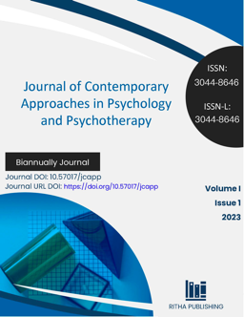
Journal DOI: 10.57017/jcapp
Journal URL DOI: https://doi.org/10.57017/jcapp

Disclosure of interests
Authors are required to provide a clear and comprehensive disclosure of their financial and non-financial interests that could be perceived as influencing the research or its interpretation in the paper entitled:

Title: __________________________________________________________________________________________________

From which, Corresponding Author is:

First name: ___________________________________ Last name: ____________________________________

☐ The authors declare that they have no known competing financial interests or personal relationships that could have appeared to influence the work reported in this paper.

☐ The authors declare the following financial interests/personal relationships which may be considered as potential competing interests:

☐ The authors complete this declaration if it is the case:
During the preparation of this work the author(s) used [NAME TOOL / SERVICE] in order to [REASON]. After using this tool/service, the author(s) reviewed and edited the content as needed and take(s) full responsibility for the content of the publication.

Signature: ____________________________________

These interests may be personal, professional, or institutional in nature.
This declaration does not apply to the use of basic tools for checking grammar, spelling, references etc. If there is nothing to disclose, there is no need to add a statement.

