**Call for Book Chapters Contributions**

**in the book entitled:**

**“An In-Depth Exploration of Technology Business Management: Applications, Challenges and Solutions"**

**EDITORS**:

[PhD Laura NICOLA-GAVRILĂ](https://scholar.google.com/citations?user=ggfVSO0AAAAJ&hl=en) and [PhD Roman VAVREK](https://scholar.google.com/citations?hl=en&user=R8xRvgUAAAAJ&view_op=list_works&sortby=pubdate)

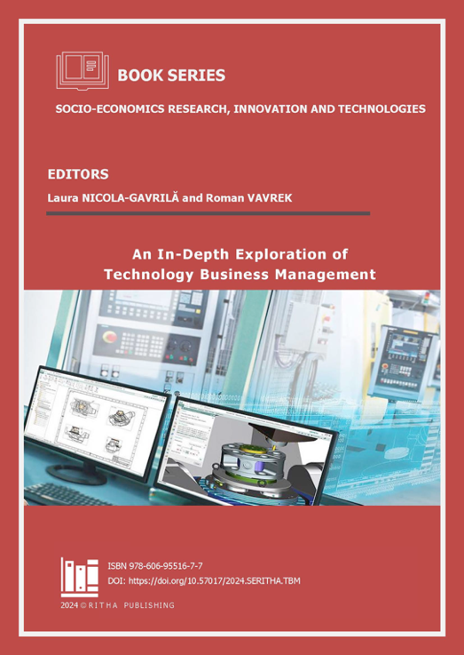

ISBN: 978-606-95516-7-7

DOI: <https://doi.org/10.57017/2024.SERITHA.TBM>

in Book Series:

**Socio-Economics Research, Innovation and Technologies**

DOI: <https://doi.org/10.57017/2024.SERITHA>

In the dynamic landscape of today's technological advancements, understanding and effectively exploring the complex connection of technology with business processes is utmost. As technology continues to evolve at an unprecedented manner, the need for a nuanced comprehension of its impact on business operations has never been more necessary.

This book emerges as a vision, guiding readers through a rich and detailed exploration of Technology Business Management (TBM), unravelling its particulars and promotion the transformative potential it holds for organizations across businesses.

We seek contributors who can offer a diverse range of expertise to provide a deep dive into the multifaceted aspects of TBM. From laying down its foundational principles to clarifying practical applications, each chapter in the book will be accurately crafted to deliver both conceptual insights and actionable strategies. The objective is to move beyond theoretical discourse, offering readers real-world perspectives through engaging case studies, and best practices that enlighten the path toward effective technology-driven business management.

We encourage contributors to submit original papers that combine theoretical insights with practical applications, fostering a nuanced understanding of TBM. Submissions should be original and innovative, contributing to the collective knowledge and advancement of Technology Business Management. The following are suggested topics for research but are not limited to:

* Foundational Principles of Technology Business Management:
* Analysing the core principles that form the basis of TBM
* Examining the historical evolution and theoretical frameworks of TBM
* Practical Applications and Implementation Strategies:
* Showcasing successful case studies of TBM implementation in diverse organizational settings
* Providing practical insights into the challenges and opportunities associated with TBM adoption
* Integration of Technology and Business Operations:
* Investigating how TBM enhances the integration of technology within overall business operations
* Exploring the impact of TBM on organizational efficiency, agility, and decision-making processes
* Data Analytics and Technology Business Management:
* Exploring the role of data analytics in optimizing TBM practices
* Assessing the impact of data-driven decision-making on technology-related investments and resource allocation
* Innovation in Technology Business Management:
* Examining how TBM fosters innovation within organizations
* Identifying the relationship between TBM and technological advancements
* Artificial Intelligence and Automation in TBM:
* Investigating the integration of artificial intelligence in TBM frameworks
* Assessing the role of automation in optimizing technology-related processes
* Challenges and Solutions in Technology-Driven Business Management:
* Identifying common challenges faced by organizations in implementing TBM
* Proposing effective solutions and best practices to overcome TBM-related obstacles
* Future Trends in Technology Business Management:
* Predicting emerging trends and developments in the field of TBM
* Speculating on the future role of TBM in shaping technology and business landscapes.

We welcome contributions from scholars, researchers, practitioners, and industry experts to collectively enrich the field on Technology Business Management. The book will to be a good reference source for information and knowledge professionals and can be read by both graduate and undergraduate students.

The new book will be published in on-line or print (only on demand due the costs) format with eISBN/ISBN and DOI assigned. For a better dissemination of research findings will be indexed and listed in international catalogues and databases as: CEEOL, Worldcat, EBSCO, EconLit, RePEC, send for evaluation to SCOPUS and CLARIVATE - Web of Knowledge.

**SUBMISSION PROCEDURE:**

Potential contributors are invited to submit before 25th of February, 2024 2-3 pages chapter proposal clearly explaining the mission and concerns of their proposed chapter. Contributors of accepted proposals will be notified by 7th of March, 2024 regarding the status of their proposals. For keeping a reasonable trade-off between theoretical and practical issues, a careful selection of the chapters will be done, on the one hand, to cover a broad spectrum of formal and practical aspects and, on the other hand, to achieve as much as possible a self-contained book. Full chapters are expected to be submitted till 25th of April, 2024.

**IMPORTANT DATES:**

Preliminary Abstract Due: 15th of January, 2025

Abstract Acceptance Notification: 30th of January, 2025

Full Manuscript/Chapter Due: **15th of March, 2025**

Acceptance of Chapter Notification: 30th of March, 2025

Final Camera-Ready Manuscript/Chapter Due: 15th of April, 2025

Publication Date: **30th of April, 2025**

For publishing inquiries, please feel free to contact the editorial office at: [books@ritha.eu](mailto:books@ritha.eu) or the Editors at [ng.laura@ritha.eu](mailto:ng.laura@ritha.eu) and [vavrek.roman@gmail.com](mailto:vavrek.roman@gmail.com).