JCMIH Vancouver Reference Style – Quick Guide

JCMIH uses the Vancouver referencing style, based on the recommendations of the International Committee of Medical Journal Editors (ICMJE) and the reference conventions of the U.S. National Library of Medicine (NLM).
References must be numbered consecutively in the order in which they are first cited in the manuscript. Each reference must retain the same number throughout the manuscript. The reference list must be presented in numerical order, not alphabetically.

In-Text Citations
Situation | JCMIH Style
Single reference | [1]
Two or more non-consecutive references | [2,5,8]
Consecutive references | [4-7]
Combined references | [2,4-7,10]
Citation numbers should be placed before the punctuation mark.
Example: Artificial intelligence is increasingly used for diagnostic decision support in clinical medicine [1,2].
Reference List – Source Types
Source Type | JCMIH Vancouver Format
Journal article – up to 6 authors | Author AA, Author BB. Article title. Abbreviated Journal Title. Year;Volume(Issue):Pages. https://doi.org/...
Journal article – 7+ authors | Author AA, Author BB, Author CC, Author DD, Author EE, Author FF, et al. Article title. Abbreviated Journal Title. Year;Volume(Issue):Pages. https://doi.org/...
Book | Author AA, Author BB. Book title. Edition. Place: Publisher; Year.
Book chapter | Author AA. Chapter title. In: Editor BB, Editor CC, editors. Book title. Edition. Place: Publisher; Year. p. xx-xx.
Website / Online resource | Author/Organisation. Title [Internet]. Place: Publisher; Year [cited YYYY Mon DD]. Available from: URL
Dataset | Author/Organisation. Dataset title [dataset]. Repository; Year. DOI/URL
Preprint | Author AA, Author BB. Article title [Preprint]. Repository; Year. DOI/URL
Clinical trial / Registry record | Investigator/Organisation. Study title [clinical trial record]. Registry name. Registration No. XXXXX. Year. Available from: URL
Software / Code / Repository | Author/Developer. Software or repository title [software]. Version. Repository/Publisher; Year. DOI/URL
Examples
Journal article – up to six authors
- TeSlaa T, Ralser M, Fan J, Rabinowitz JD. The pentose phosphate pathway in health and disease. Nat Metab. 2023;5(8):1275-1289. https://doi.org/10.1038/s42255-023-00863-2
Journal article – seven or more authors
- Wang Y, Zhou L, Zhao Y, Wang S, Chen L, Liu L, et al. Regulation of G6PD acetylation by SIRT2 and KAT9 modulates NADPH homeostasis and cell survival during oxidative stress. EMBO J. 2014;33(12):1304-1320. https://doi.org/10.1002/embj.201387224
Important Formatting Rules
Author names and initials. Write the surname followed by the author's initial(s), without commas or full stops between them: Popescu A, not Popescu, A.
Number of authors. List up to six authors. For works with seven or more authors, list the first six authors followed by et al.
Journal titles. For journals indexed in MEDLINE/NLM, use the official abbreviated journal title listed in the NLM Catalog; for example, N Engl J Med rather than New England Journal of Medicine. If no official NLM abbreviation is available, use the full journal title. ICMJE specifically directs authors to MEDLINE journal-title abbreviations.
Year, volume, issue and pages. Do not insert spaces between these elements:
2024;70(3):145-152 not 2024; 70 (3): 145-152
DOI. Where available, provide the DOI as a complete persistent URL:
https://doi.org/10.xxxx/xxxxx
Reference accuracy. Authors are responsible for ensuring that references accurately support the statements for which they are cited. Bibliographic information should be verified against PubMed or the original publication, and authors should check whether cited articles have been retracted. This directly reflects current ICMJE guidance.
Original sources. Original research articles should be cited whenever possible. Excessive or unnecessary reference lists should be avoided.
Preprints. Preprints may be cited where scientifically relevant but must be clearly identified as preprints.
Datasets. Where datasets are cited, authors should provide their unique persistent identifiers whenever available.
AI-generated material. Generative AI tools or AI-generated material must not be cited as primary sources.
Further Reference Guidance
For reference types not covered in this Quick Guide, authors should follow the reference formats provided in the NLM Citing Medicine guidance. ICMJE itself now directs authors to NLM's Citing Medicine rather than maintaining its own comprehensive list of citation formats.
For a concise visual overview of the JCMIH Vancouver reference requirements, see Figure 1 below.

Figure 1: JCMIH Vancouver Reference Style at a Glance
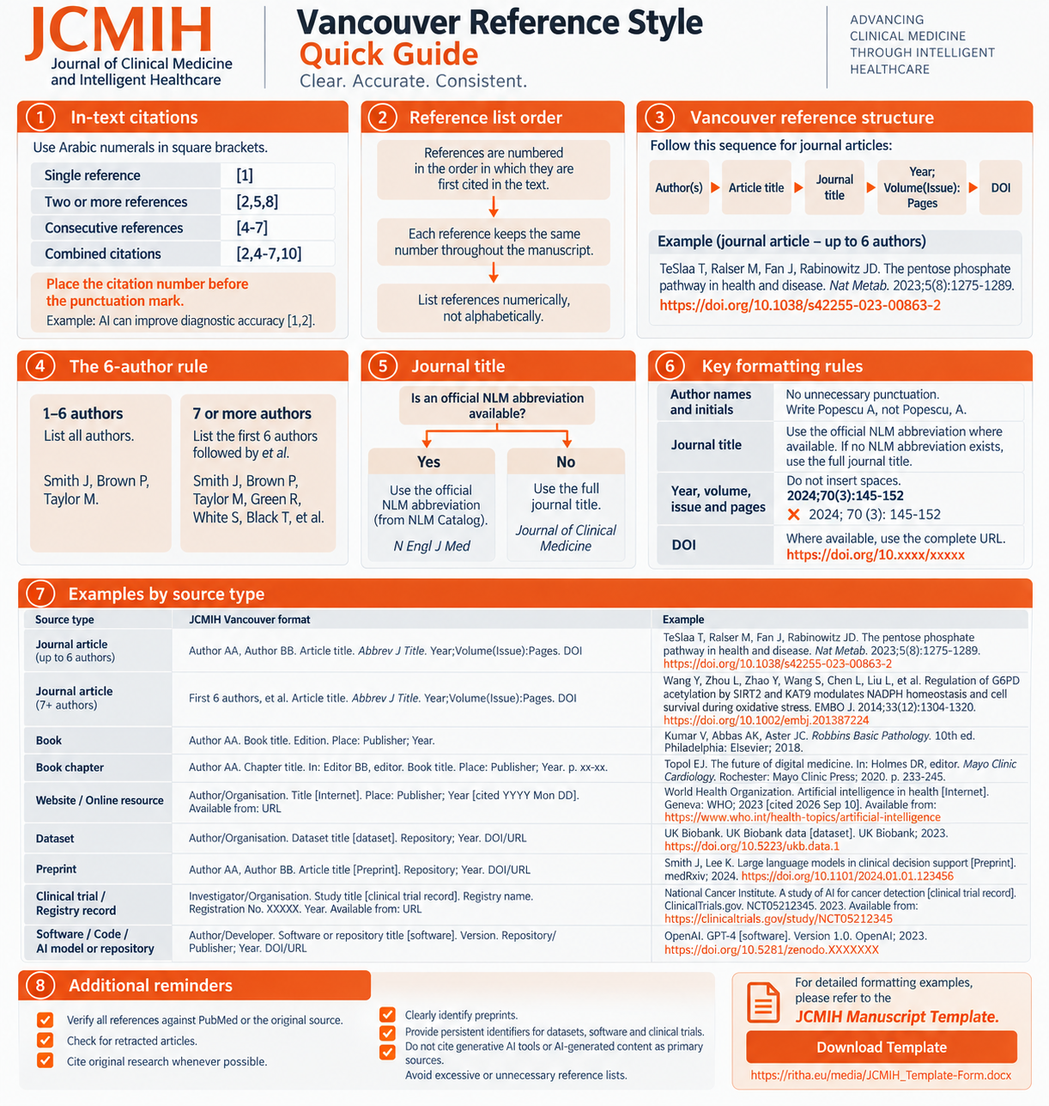
Source: JCMIH Editorial Team

