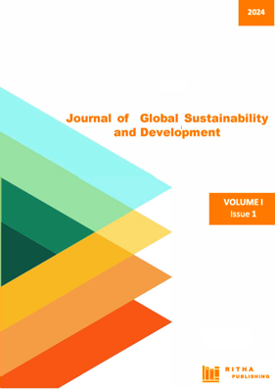
Journal DOI: 10.57017/jgsd
Journal URL DOI: https://doi.org/10.57017/jgsd
Journal Issue URL DOI: https://doi.org/10.57017/jgsd.v1.i1

Author(s) License Agreement

This Agreement refers to the manuscript of the article having the title and the authors as below:
The Title of the Article (hereinafter, ‘Article’):

Author(s): #1. First name: ___________________________________Last name: _________________________________
#2. First name: ___________________________________ Last name: _________________________________
#3. First name: ___________________________________ Last name: _________________________________
#4. First name: ___________________________________ Last name: _________________________________
Authors who publish with this journal agree to the following terms of Non-Exclusive License under Attribution 4.0 International Public License (CC BY 4.0):
- Authors retain copyright and grant the journal right of first publication with the work simultaneously licensed under a Creative Commons Attribution License (CC BY 4.0) that allows others to share the work with an acknowledgement of the work's authorship and initial publication in this journal.
- Authors are able to enter into separate, additional contractual arrangements for the non-exclusive distribution of the journal's published version of the work (e.g., post it to an institutional repository or publish it in a book), with an acknowledgement of its initial publication in this journal.
- Authors are permitted and encouraged to post their work online (e.g., in institutional repositories or on their website) prior to and during the submission process, as it can lead to productive exchanges, as well as earlier and greater citation of published work. Authors are recommended to archive the published version in institutional repositories. In this regard, please see the section "How to cite" from the article's web page. E.g.: https://ritha.eu/journals/JGSD/issues/1/articles/1
Authorized Signature (of corresponding author): ____________________________________ Date:_________________

Full Name of corresponding author (printed): _______________________________________________________________

Third Party(ies) Signature(s) (if necessary): __________________________________

This form must be signed at least by Corresponding Author in order as appeared in the article, and should be returned to the editorial office. Please e-mail a scanned copy of the completed and signed original of this Agreement (retaining a copy for your file) to journals@ritha.eu.

