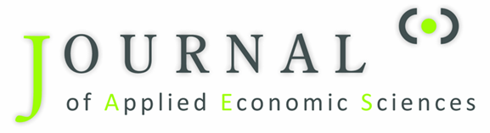

Researchers interested in coordinating a Special Issue in the Journal of Applied Economic Sciences (JAES) are invited to submit a proposal using the form below. The proposal will be evaluated by the Editor-in-Chief and the Editorial Board based on scientific relevance, feasibility, and alignment with the journal’s aims and scope.
Please complete all sections of this form.

1. Proposed Title of the Special Issue
Provide the proposed title.

2. Rationale and Scope (300–500 words)
Describe the academic motivation for the Special Issue. The description should include:
- the importance of the proposed topic;
- its relevance for applied economic sciences;
- expected scientific and policy contributions;
- how the Special Issue aligns with the scope of JAES.

3. Main Themes and Topics
List the key research themes that the Special Issue will address.

4. Relevance to JAES
Explain how the proposed Special Issue aligns with the aims and scope of the Journal of Applied Economic Sciences.

5. Proposed Guest Editor(s)
Provide details for each proposed Guest Editor.

Lead Guest Editor
Name:
Institution:
Country:
ORCID:
Email:
Short Academic Biography (100–150 words)

Associate Guest Editor (optional)
Name:
Institution:
Country:
ORCID:
Email:
Short Academic Biography:

6. Expected Number of Papers
Indicate the estimated number of manuscripts expected for submission.
Note: Special Issues typically contain 10–25 accepted papers.

7. Proposed Timeline
Please indicate the proposed timeline for the Special Issue.
Example:
Call for Papers launch:
Submission deadline:
Peer review period:
Revision period:
Expected publication date:

9. Promotion Strategy
Describe how the Special Issue will be promoted.
Examples:
- academic mailing lists
- research networks
- conferences and workshops
- social media channels
- institutional websites

10. Declaration of Editorial Responsibility
The proposed Guest Editor(s) confirm that they will conduct the coordination of the Special Issue in accordance with the editorial policies and ethical standards of the Journal of Applied Economic Sciences (JAES) and the guidelines established by RITHA Publishing House.
The Guest Editor(s) agree to:
- ensure fair and transparent manuscript handling;
- follow the double-blind peer review process;
- recommend qualified and independent reviewers;
- avoid conflicts of interest and disclose any potential conflicts;
- refrain from handling manuscripts authored by themselves or close collaborators.
The Guest Editor(s) acknowledge that final editorial decisions remain exclusively with the Editor-in-Chief of JAES.
Name(s) of Guest Editor(s):
Signature(s):
Date:

11. Submission of Proposal
Completed proposals should be sent to:
Editorial Office
Journal of Applied Economic Sciences (JAES)
RITHA Publishing House
Email: jaes-secretary@yahoo.com or journals@ritha.eu

